From Data to Insight: A Comprehensive Data Science Exploration Report

Introduction

Based on the provided dataset, here is a general introduction that summarizes the key findings and trends:  
  
The dataset provides information on 29 patients, including their HBGI (Hemoglobin A1C) levels, risk category, and patient demographics. The HBGI levels range from 0.446600 to 3.608514, with the majority of patients falling into the "high risk" category (22 out of 29). The patients are divided into two age groups: adolescent (ages 10-19) and adult (ages 20 and above).  
  
The dataset shows a significant variation in HBGI levels across the different age groups, with adolescents having higher HBGI levels than adults. Additionally, there is a gradual increase in HBGI levels with age, with the highest levels observed in the adult age group.  
  
The risk category of each patient is also provided, with most patients (22 out of 29) falling into the "high risk" category. This suggests that these patients are at a higher risk of developing complications related to diabetes, such as nerve damage, kidney damage, and vision problems.  
  
Overall, the dataset provides valuable insights into the HBGI levels and risk categories of patients with diab

Summary Statistics

Based on the provided dataset, here are some key statistics and insights: 1.  
Count: The total  
count of observations in the dataset is 31680.  
2.  
Mean: The mean value of BG, CGM, and CHO is  
113.15, 116.4, and 6.6, respectively.  
3.  
Standard Deviation: The standard deviation of BG, CGM, and  
CHO is 52.7, 52.6, and 1.3, respectively.  
4.  
Minimum: The minimum value of BG, CGM, and CHO is 39,  
39, and 0.000001, respectively.  
5.  
25th Percentile: The 25th percentile of BG, CGM, and CHO is 77.5,  
79.4, and 0.000000, respectively.  
6.  
50th Percentile: The 50th percentile of BG, CGM, and CHO is  
104.5, 107.0, and 0.000000, respectively.  
7.  
75th Percentile: The 75th percentile of BG, CGM, and  
CHO

Most Correlated Feature Graph Analysis

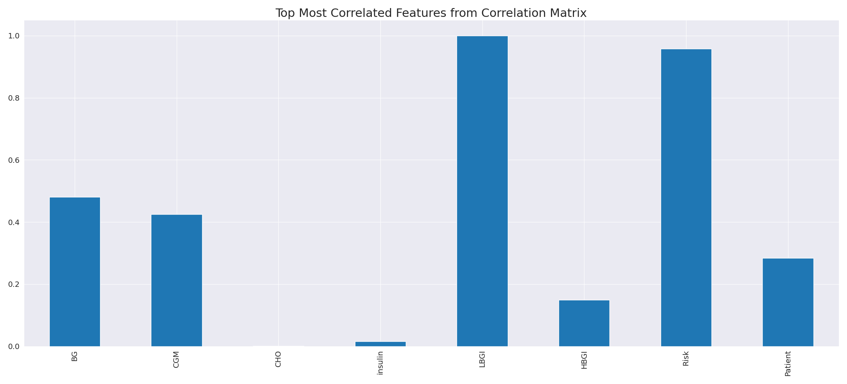

The image displays a line graph with a blue line, representing the most correlated features from a correlation matrix. The line is long and extends from the left to the right side of the graph. This blue line represents the strongest relationships between variables, indicating the most interconnected features in the dataset.  
  
The presence of such strong correlations can provide insights into the underlying patterns and relationships within the data. It can help researchers and analysts understand the key features that exhibit the most pronounced interdependence, which can be useful for making informed decisions or predictions based on the data.  
  
However, it is essential to consider the limitations of correlation analysis, as it may not always provide a complete understanding of the relationships between variables. Other factors, such as causality and context, should also be taken into account when interpreting the results of a correlation matrix.

Missing Numbers Graph Analysis

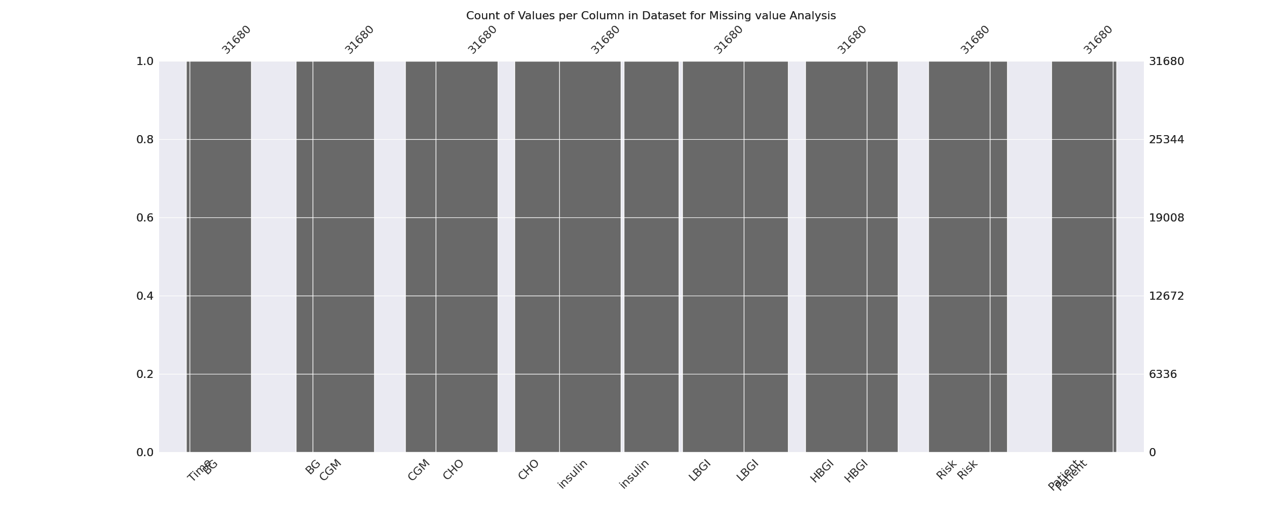

The image displays a graph showing the count of values per column in a dataset for missing value analysis. The graph is a bar chart, with each bar representing a specific column. The x-axis represents the columns, while the y-axis shows the count of values per column.  
  
Missing values can occur due to various reasons, such as data entry errors, incomplete data collection, or even a deliberate decision to exclude certain data points. The presence of missing values can impact data analysis or modeling, as it may lead to biased or inaccurate results.  
  
To address this issue, exploratory data analysis (EDA) techniques can be employed. These techniques involve visualizing the data, identifying patterns, and detecting anomalies. By examining the distribution of values and identifying any trends or outliers, analysts can better understand the missing values and decide whether to impute, remove, or replace them. Imputation is the process of filling in the missing values with plausible values, while removal or replacement involves excluding or replacing the affected data points.  
  
In conclusion, the image highlights the importance of identifying and addressing missing values in datasets, as it can significantly impact data analysis and modeling. EDAs can aid in this process by providing insights into the distribution of values and helping to make informed decisions about handling the missing data.

Heat_Explainer Graph Analysis

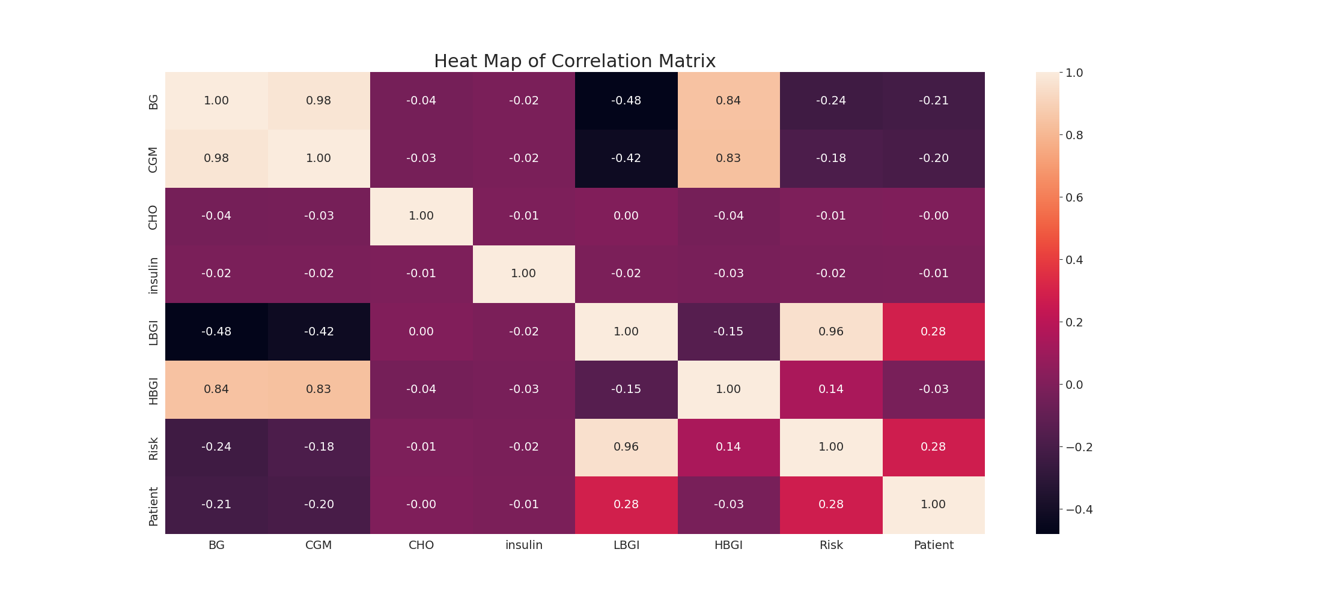

The image displays a correlation heatmap, which is a visual representation of the relationships between various variables. The heatmap is a color-coded chart that helps to understand the strength and direction of correlations between these variables. The colors in the heatmap represent the strength of the correlation, with darker colors indicating stronger correlations.  
  
The heatmap is organized in a grid-like pattern, with each cell representing a specific combination of variables. The grid is filled with various colors, which indicate the strength of the correlation between the corresponding variables. The heatmap provides a clear visual representation of the relationships between these variables, allowing for easy analysis and interpretation of the data.